EXPERIMENT NO. 4

AIM: To perform testing and Deployment using Jenkins.
THEORY:
Creating a Build Using Jenkins
Step 1: From the Jenkins interface home, select New Item.
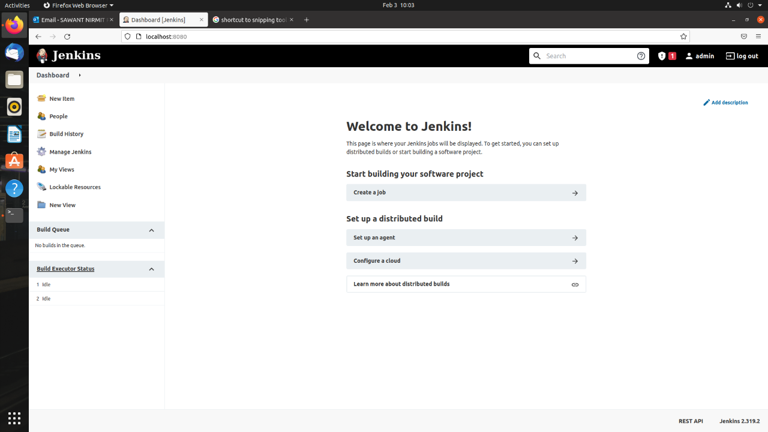

Step 2: Enter a name and select Freestyle project.
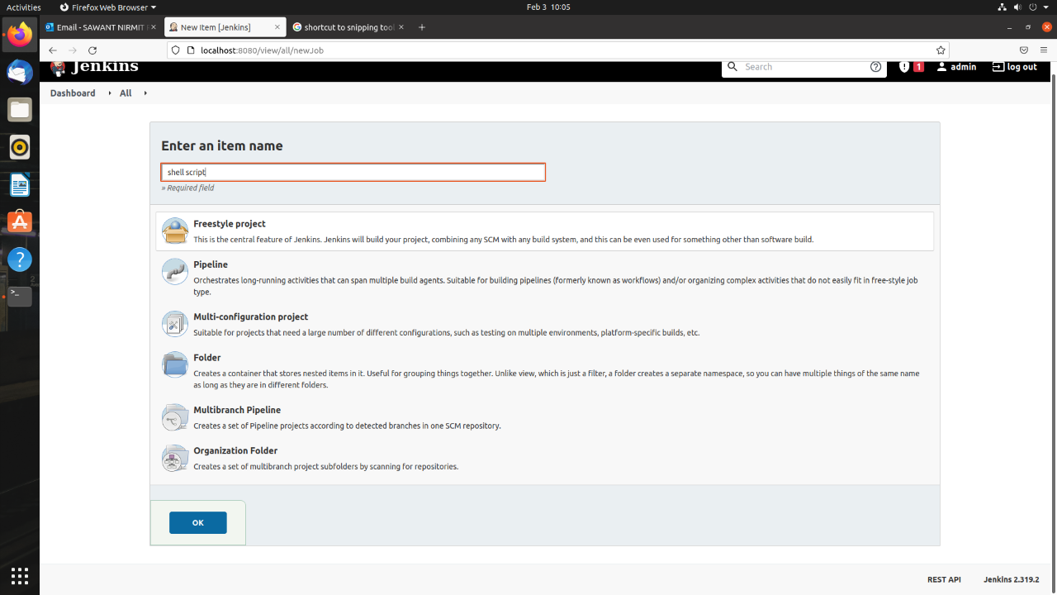

Step 3: This next page is where you specify the job configuration. As you’ll quickly observe, there are a number of settings available when you create a new project. On this configuration page, you also have the option to Add build step to perform extra actions like running scripts. I will execute a shell script.
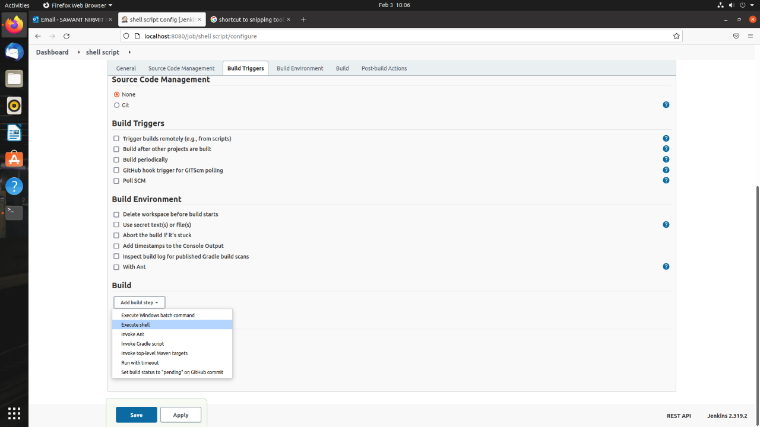

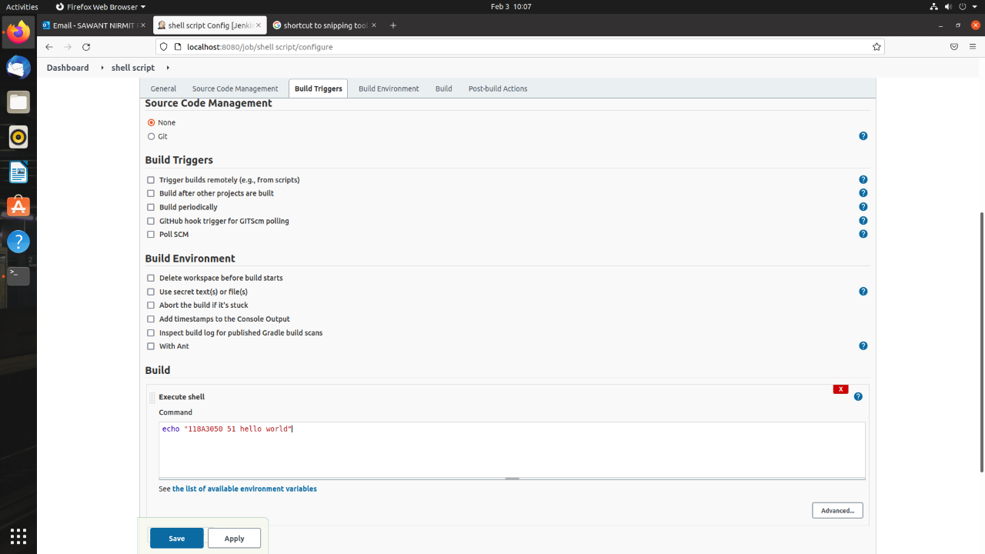

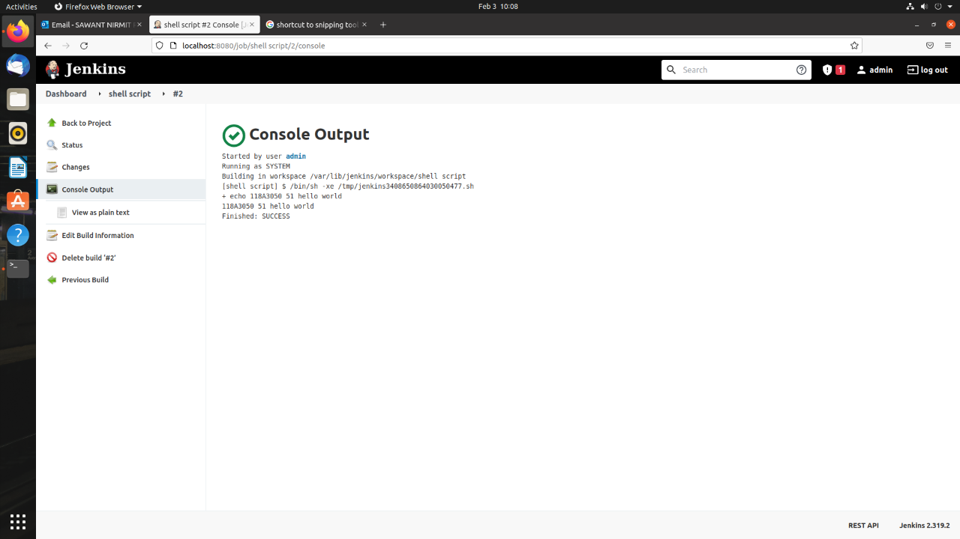

Integration of github repository with Jenkins.

Configuring GitHub
Step 1: go to your GitHub repository and click on ‘Settings’
Step 2: Click on Webhooks and then click on ‘Add webhook’.
Step 3: in the ‘Payload URL’ field, paste your Jenkins environment URL. At the end of this URL add
/github-webhook/. In the ‘Content type’ select ‘application/json’ and leave the ‘Secret’ field empty.
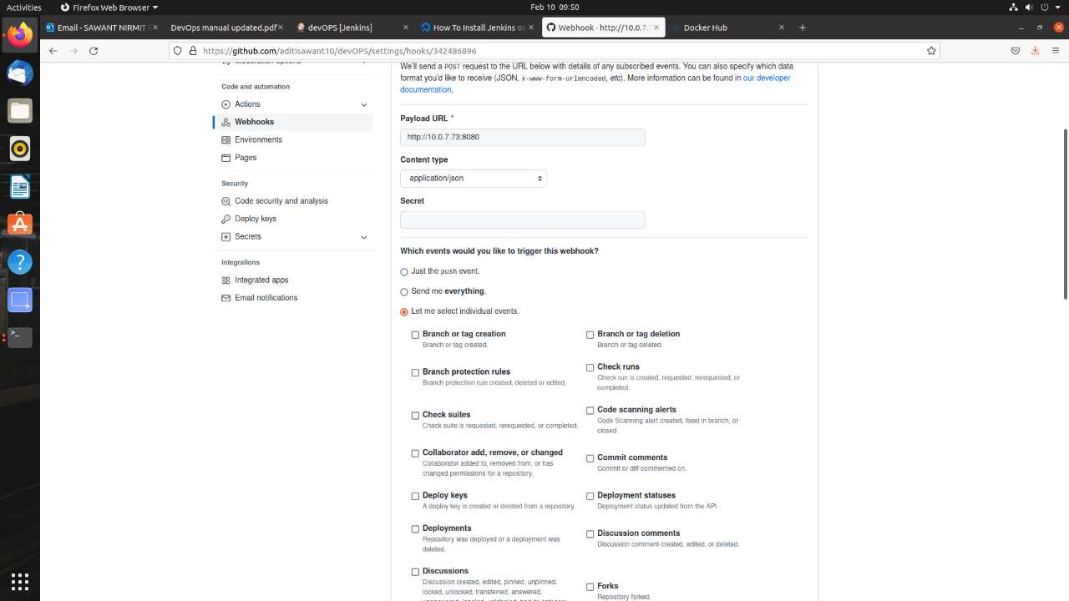
Step 4: in the ‘Which events would you like to trigger this webhook?’ choose ‘Let me select individual
events.’ Then, check ‘Pull Requests’ and ‘Pushes’. At the end of this option, make sure that ‘Active’ is
checked and click on ‘Add webhook’.
Step 5: In Jenkins, click on ‘New Item’ to create a new project.
Step 6: Give your project a name, them choose ‘Freestyle project’ and finally click on ‘OK’.
Step 7: Click on the ‘Source Code Management’ tab.
Step 8: Click on Git and paste your GitHub repository URL in the ‘Repository URL’ field.
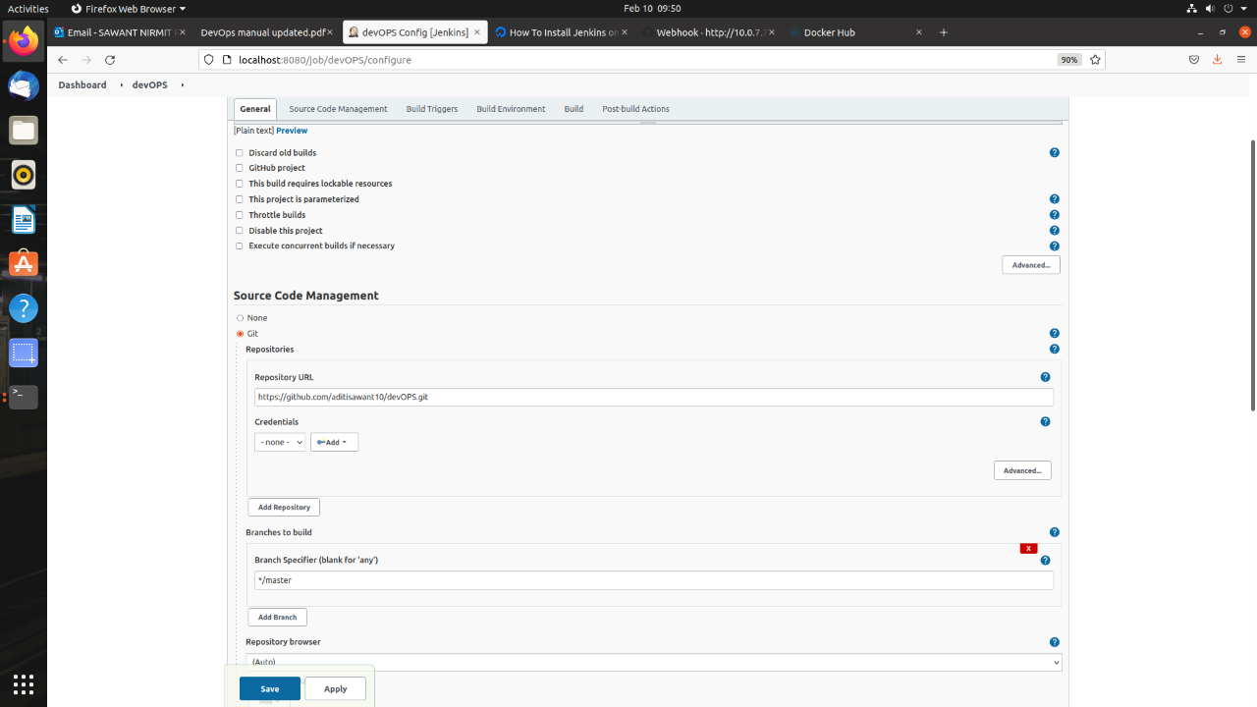
Step 9: Click on the ‘Build Triggers’ tab and then on the ‘GitHub hook trigger for GITScm polling’. Or,
choose the trigger of your choice.
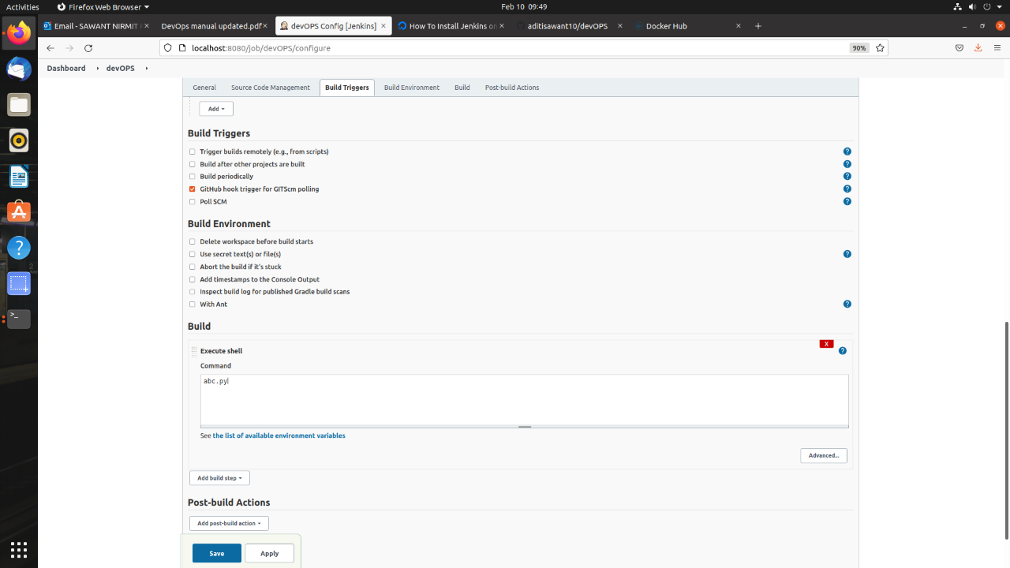
That's it! Your GitHub repository is integrated with your Jenkins project.
Step 10: Click on the ‘Build’ tab, then click on ‘Add build step’ and choose ‘Execute shell’.
Conclusion: Thus, we have successfully performed testing and Deployment using Jenkins.

